LOAN APPLICATION BLOG

INTRODUCTION
What is a Loan?
A loan is a sum of money that one or more individuals or companies borrow from banks or other financial institutions so as to financially manage planned or unplanned events. In doing so, the borrower incurs a debt, which he must pay back with interest and within a given period.
Who Applies for Loan?
Throughout the world people apply loans for various reasons, they can be personal loan, home loan, student loan, etc. How do they decide they are eligible? And based on what criteria are they eligible?
There are many criterions as to which the company or firm decides to approve the applicant or not, a few of the criterions are present in our dataset.
We have a dataset for which the applications were either approved or not, according to the criterion of the applicant given below:
Loan_ID: ID of the Applicant
Gender: Male / Female
Married: Yes / No
Dependents: Number of dependents
Education: Graduated / Ungraduated
Self_Employed: Yes / No
ApplicantIncome: Applicant Income
CoapplicantIncome: Co-Applicant Income
LoanAmount: Amount on Loan
Loan_Amount_Term: Time to pay back the loan in Months
Credit_History: Credit History meet guidelines, Yes / No
Property_Area: Urban/ Semi Urban/ Rural
Loan_Status: Approved or Not (Yes / No)

Exploratory Data Analysis
I have used seaborn for and Visualization and pandas for manipulation of Data.
Let’s import the necessary libraries for plotting graphs, manipulating of data and importing the data set as given below:

import numpy as np
import matplotlib.pyplot as plt
import seaborn as sns
import warnings
warnings.filterwarnings('ignore')
import pandas as pd
df=pd.read_csv('Loan Application Status Prediction.csv')
df
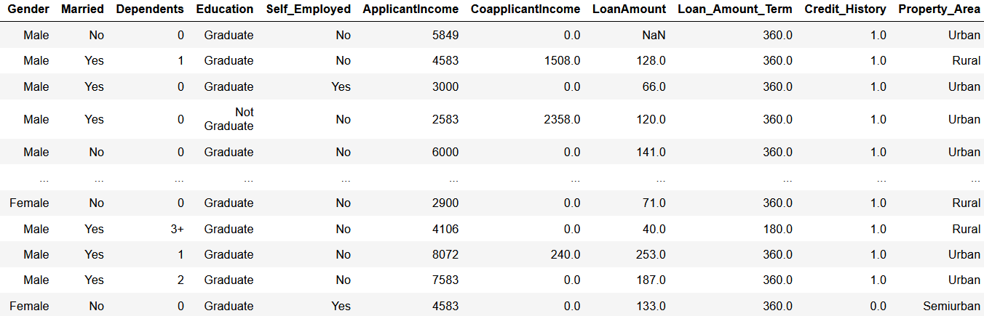
614 rows × 13 columns

Data-Set Information
RangeIndex: 614 entries, 0 to 613
Data columns (total 13 columns):
# Column Non-Null Count Dtype
--- ------ -------------- -----
0 Loan_ID 614 non-null object
1 Gender 601 non-null object
2 Married 611 non-null object
3 Dependents 599 non-null object
4 Education 614 non-null object
5 Self_Employed 582 non-null object
6 ApplicantIncome 614 non-null int64
7 CoapplicantIncome 614 non-null float64
8 LoanAmount 592 non-null float64
9 Loan_Amount_Term 600 non-null float64
10 Credit_History 564 non-null float64
11 Property_Area 614 non-null object
12 Loan_Status 614 non-null object

There are a total of 614 Rows and 13 Columns of which 8 are ‘Object’, 4 are ‘float’ and 1 is an ‘int’ datatype. We can notice there are missing values in these columns.

Unique Values For Object Columns
Gender : ['Male' 'Female' nan]
Married : ['No' 'Yes' nan]
Dependents : ['0' '1' '2' '3+' nan]
Education : ['Graduate' 'Not Graduate']
Self_Employed : ['No' 'Yes' nan]
Property_Area : ['Urban' 'Rural' 'Semiurban']
Loan_Status : ['Y' 'N']

Null Values
First let’s check in which columns there are Null Values present in the dataset:
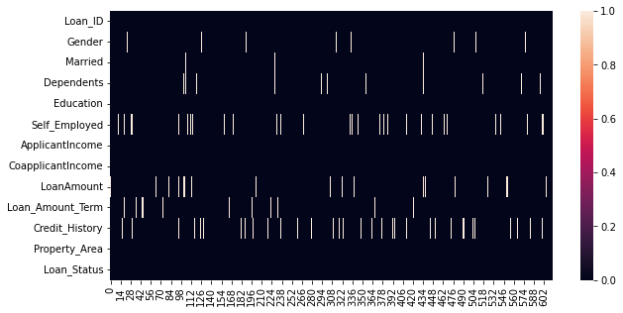

Loan_ID 0
Gender 13
Married 3
Dependents 15
Education 0
Self_Employed 32
ApplicantIncome 0
CoapplicantIncome 0
LoanAmount 22
Loan_Amount_Term 14
Credit_History 50
Property_Area 0
Loan_Status 0
dtype: int64

From the plot diagram and information, we can see few missing values in columns: Gender, Married, Dependents, Self_Employed, LoanAmount, Loan_Amount_Term, Credit_History. There are different ways of solving missing values, we can either drop them, fill according to most occurred value or mean etc.

I have replaced the missing values of LoanAmount with mean of it and Loan_Amount_Term with its mode and dropped the rest of the missing values as well as dropped ‘Loan_ID’ column since it does not have a relation with eligibility of applicant as shown below.

df['LoanAmount']=df['LoanAmount'].replace(np.nan,np.mean(df['LoanAmount']))
df['Loan_Amount_Term']=df['Loan_Amount_Term'].replace(np.nan,stat.mode(df['Loan_Amount_Term']))
df.drop('Loan_ID',axis=1,inplace=True)
df=df.dropna()
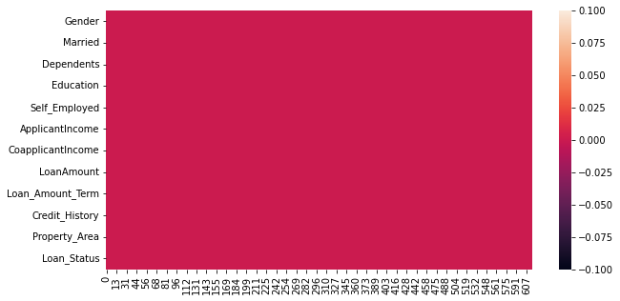

Graphical Visualization of Data

Loan Amount
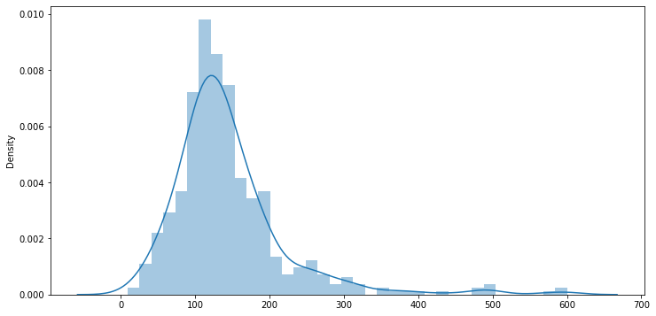
This is a graphical representation of “Loan Amount” taken by the Applicants, we can see that it is Right Skewed plot of range 100~200. We can also see that there are very few that apply for a loan of 500 and 600, In this graph there are outliers noticeable between 400~600.

Self Employed
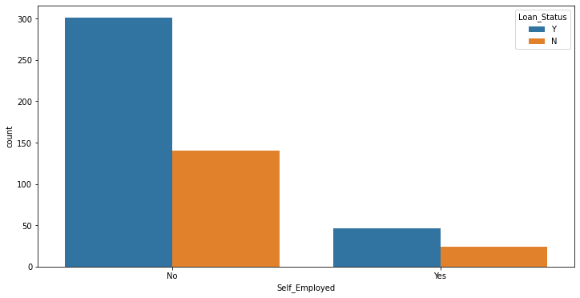

Property Area
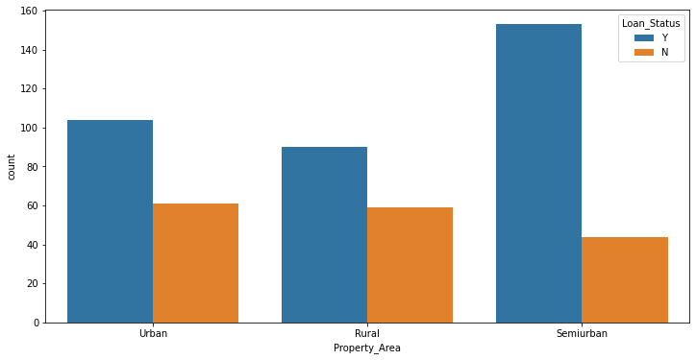

Converting Datatypes
Now we will convert all the categorical variables into numbers using LabelEncoder in sklearn.
from sklearn.preprocessing import LabelEncoder
enc=LabelEncoder()
col=['Gender', 'Married', 'Dependents', 'Education','Self_Employed', 'Property_Area', 'Loan_Status']
for i in col:
df[i]=enc.fit_transform(df[i].values.reshape(-1,1))

# Converting 'float' to 'int'
df['Credit_History'] = df['Credit_History'].astype(int)

Here we have converted columns ('Gender', 'Married', 'Dependents', 'Education','Self_Employed', 'Property_Area', 'Loan_Status') to numbers for model training and further data analysis.

Data Description:

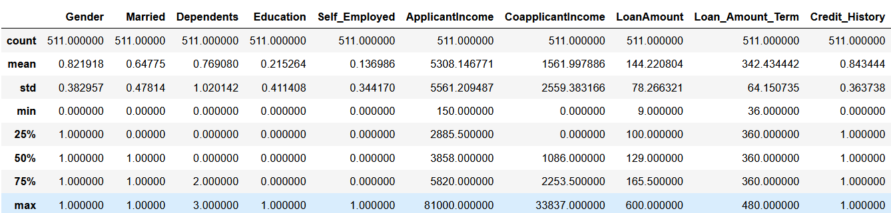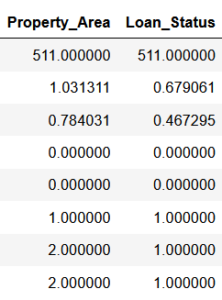

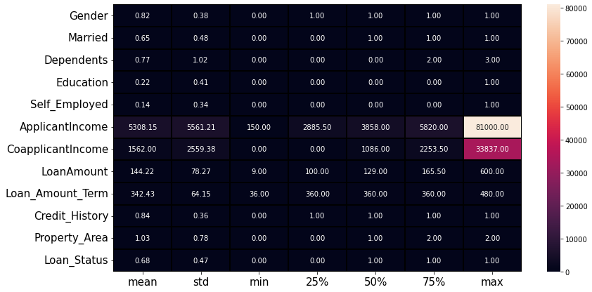

From the plot and Data Frame we can study and analyze the statistical structure of the dataset, we can see outliers present in Applicant Income since mean and Q3(3rd Quartile) are close to each other and difference between Q3 and mx is very large, and outliers is also present in Co-applicant Income where max far more than Q3 compared to Q2 and Q3, and in LoanAmount also is the same case as the previous ones.

Credit_History is more than 0.5 i.e 0.84 it means there is more occurrence 1 (Credit History meet guidelines: Yes), since there are only to values 0,1.
There are married applicants of about 65% who apply for loans compared to unmarried applicants.
But the are only 22% of the applicants that have Graduated.

Correlation of Data:
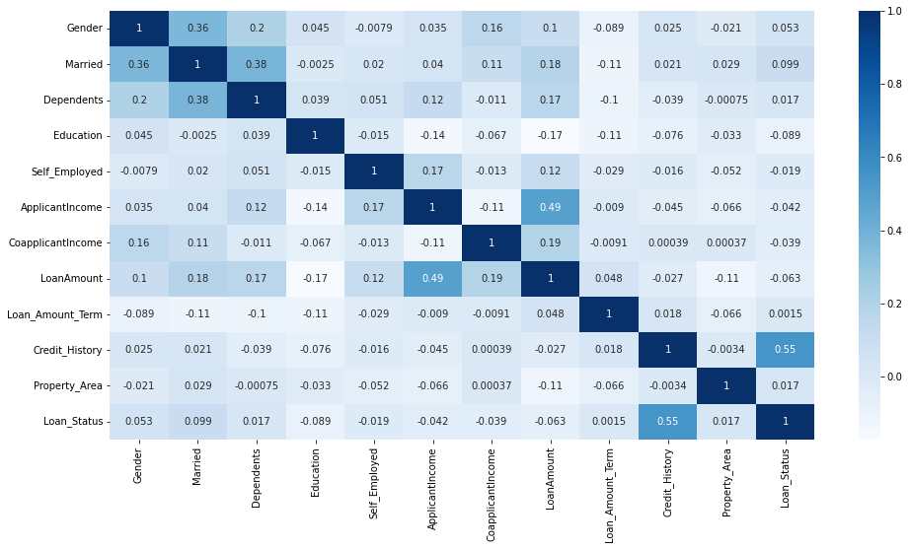
In this Correlation plot diagram we can study the relationship between columns, the columns Loan_Status and Credit_History have the highest correlation to each other of 0.55, and correlation of LoanAmount and ApplicantIncome being 0.49.
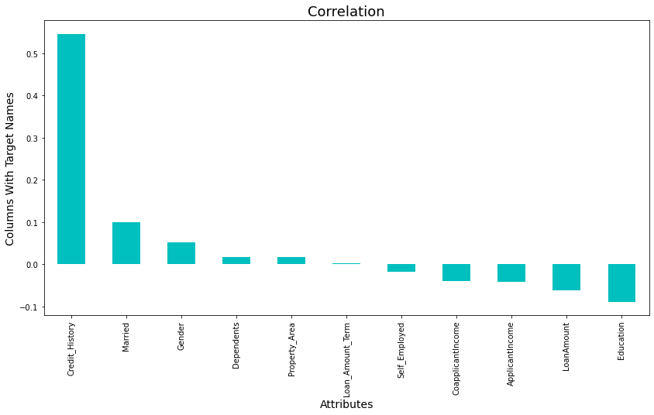
The above plot is the correlation between Loan_Status (Target Column) and the other columns (Feature columns) with Credit_History having the high positive correlation and Education having a negative correlation with Loan_Status column.

Removing Outliers
As we have seen in the previous Graphical diagram and Data Frames, there are outliers present that can bring errors in Model Training. We can use import ‘Z-score’ to remove outliers as given below:

from scipy.stats import zscore
z=np.abs(zscore(df.iloc[:,:11]))
threshold=3
df_new=df[(z<3).all(axis=1)]
x=df_new.drop(['Loan_Status'],axis=1)
y=df_new['Loan_Status']

As seen in the code, after removing outliers we have 480 rows left, later we separated the dataset into Feature columns as ‘X’ and Target column as ‘Y’. Next is balancing the data.

Data Balancing
import sklearn
from imblearn.over_sampling import SMOTE
smt=SMOTE()
x_new,y=smt.fit_resample(x,y)
x=pd.DataFrame(x_new,columns=x.columns)

Since there was a difference of more than 50% between Accepted Applicants and Rejected Applicants, I have performed Data Balancing operation.

Min-Max Scaling
from sklearn.preprocessing import MinMaxScaler
scale=MinMaxScaler()
x_new=scale.fit_transform(x)
x=pd.DataFrame(x_new,columns=x.columns)

By importing and using MinMaxScaler library I have decreased the range of data by transforming the feature columns, due to few columns have a large range.

Skew
Gender -1.214500
Married -0.182990
Dependents 1.204683
Education 1.627463
Self_Employed 2.590842
ApplicantIncome 2.093491
CoapplicantIncome 1.230633
LoanAmount 1.065361
Loan_Amount_Term -1.694785
Credit_History -0.828117
Property_Area 0.057725
There are columns with positive skewness and negative skewness of which Self_Employed and ApplicantIncome have the highest positive skewness. Since there is skewness we will import power_transform to change the skewness in the feature columns.

from sklearn.preprocessing import power_transform
x_new=power_transform(x)
x=pd.DataFrame(x_new,columns=x.columns)

SELECTING BEST MODEL
We will apply different models for training and testing to compare with using Accuracy Score, Classification report, Confusion Matrix and Cross Validation to get the best possible working model.
First let us import the necessary libraries:

from sklearn import metrics
from sklearn.metrics import accuracy_score
from sklearn.metrics import classification_report,confusion_matrix
from sklearn.model_selection import train_test_split

Now lets try different Classifier Model.

Decision Tree Classifier
Best accuracy: 87.27272727272727 on Random State: 11
[[68 20]
[18 59]]
precision recall f1-score support

0 0.79 0.77 0.78 88
1 0.75 0.77 0.76 77

accuracy 0.77 165
macro avg 0.77 0.77 0.77 165
weighted avg 0.77 0.77 0.77 165
Cross validation score is: 0.78

Random Forest Classifier
Best accuracy: 90.30303030303031 on Random State: 67
[[68 20]
[11 66]]
precision recall f1-score support

0 0.86 0.77 0.81 88
1 0.77 0.86 0.81 77

accuracy 0.81 165
macro avg 0.81 0.81 0.81 165
weighted avg 0.82 0.81 0.81 165
Cross validation score is: 0.83

K-Neighbor Classifier
Best accuracy: 84.24242424242424 on Random State: 79
[[62 26]
[13 64]]
precision recall f1-score support

0 0.83 0.70 0.76 88
1 0.71 0.83 0.77 77

accuracy 0.76 165
macro avg 0.77 0.77 0.76 165
weighted avg 0.77 0.76 0.76 165

Support Vector Classifier
Best accuracy: 85.45454545454545 on Random State: 79
[[60 28]
[ 7 70]]
precision recall f1-score support

0 0.90 0.68 0.77 88
1 0.71 0.91 0.80 77

accuracy 0.79 165
macro avg 0.80 0.80 0.79 165
weighted avg 0.81 0.79 0.79 165
Cross validation score is: 0.79

Logistic Regression
Best accuracy: 86.66666666666667 on Random State: 83
[[63 25]
[ 8 69]]
precision recall f1-score support

0 0.89 0.72 0.79 88
1 0.73 0.90 0.81 77

accuracy 0.80 165
macro avg 0.81 0.81 0.80 165
weighted avg 0.82 0.80 0.80 165
Cross validation score is: 0.80

Gaussian Naive Bayes
Best accuracy: 86.66666666666667 on Random State: 83
[[60 28]
[ 5 72]]
precision recall f1-score support

0 0.92 0.68 0.78 88
1 0.72 0.94 0.81 77

accuracy 0.80 165
macro avg 0.82 0.81 0.80 165
weighted avg 0.83 0.80 0.80 165
Cross validation score is: 0.79

CONCLUSION
After analyzing the data from different views using plot diagram, Statistical data and Correlation, later transforming the data for changing datatypes from categorical to numbers, removing outliers, balancing the data using Scaler and adjusting skewness. The next stage that was model selection, we applied different classifiers to select the best one out of it.
And so as Random Forest Classifier is seen as the best model working with Accuracy Score: 90%, Cross Validation Score: 83% and AUC Curve: 88% as shown below.
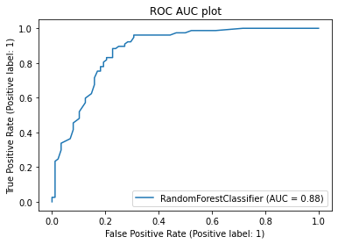
Since Random Forest Classifier model is concluded as best model, we will save the model in the below code importing ‘joblib’.

import joblib
joblib.dump(rf,'Census Income Model.pkl')

